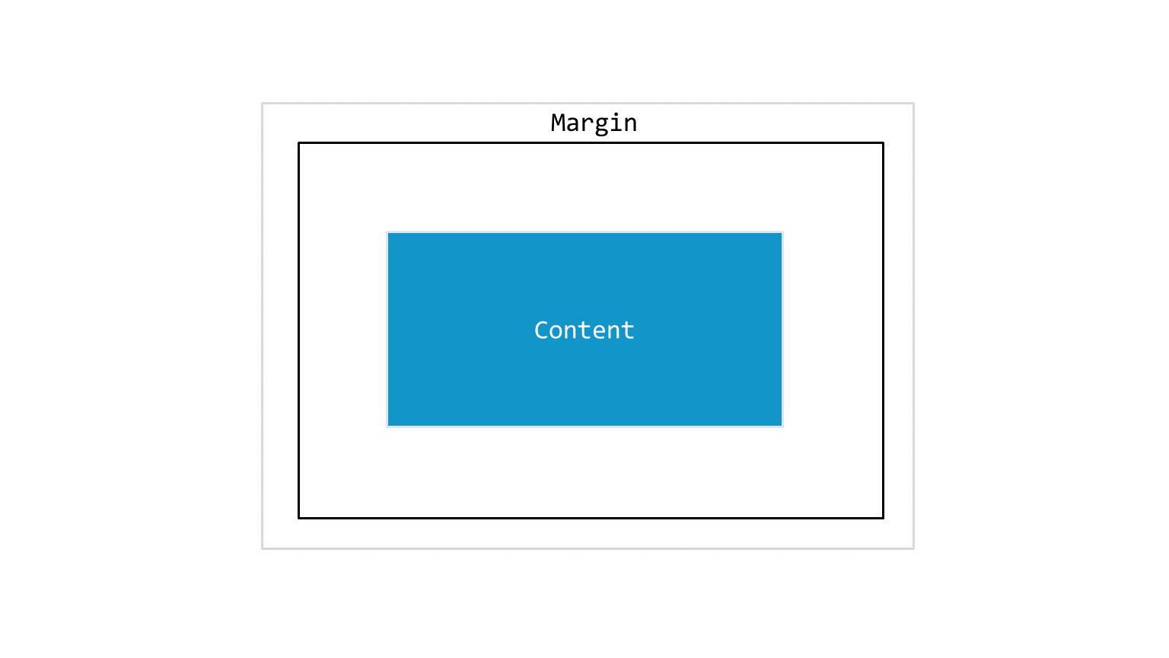
Margin

1.The margin clears an area around all the four sides of the border. If you want to give a margin of 18px on all the four sides, this is how you do it.
margin: 18px;
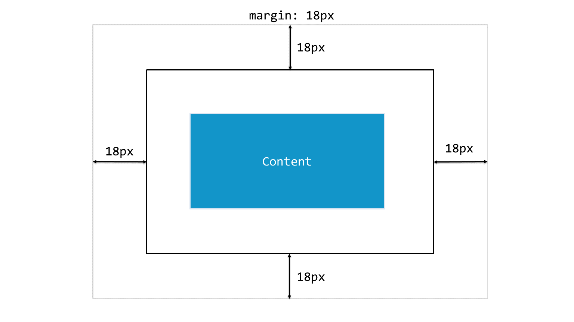

2. You can add a margin on any one side using margin-top, margin-left, margin-bottom and margin-right properties.

3. You can use these properties in combination also, suppose you want to add a margin of 8px to the left and margin of 25px to right, this is how you do it.
margin-left: 8px ;
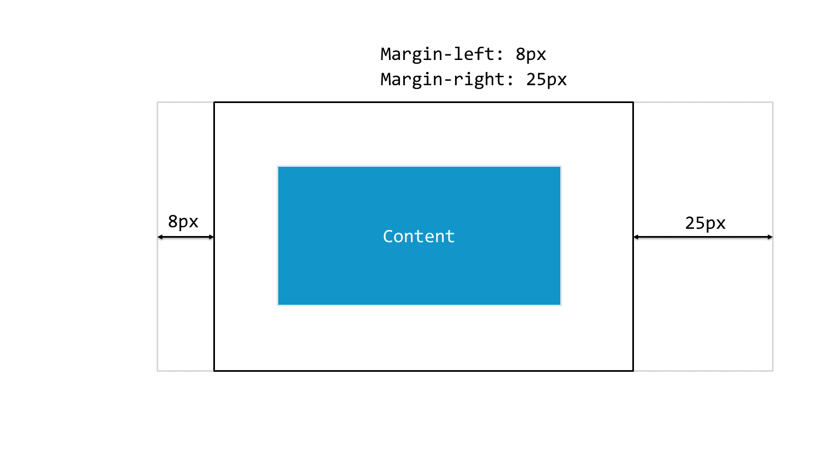
margin-right:25px;

4. You can also mention this in a single line using shorthand property like this.
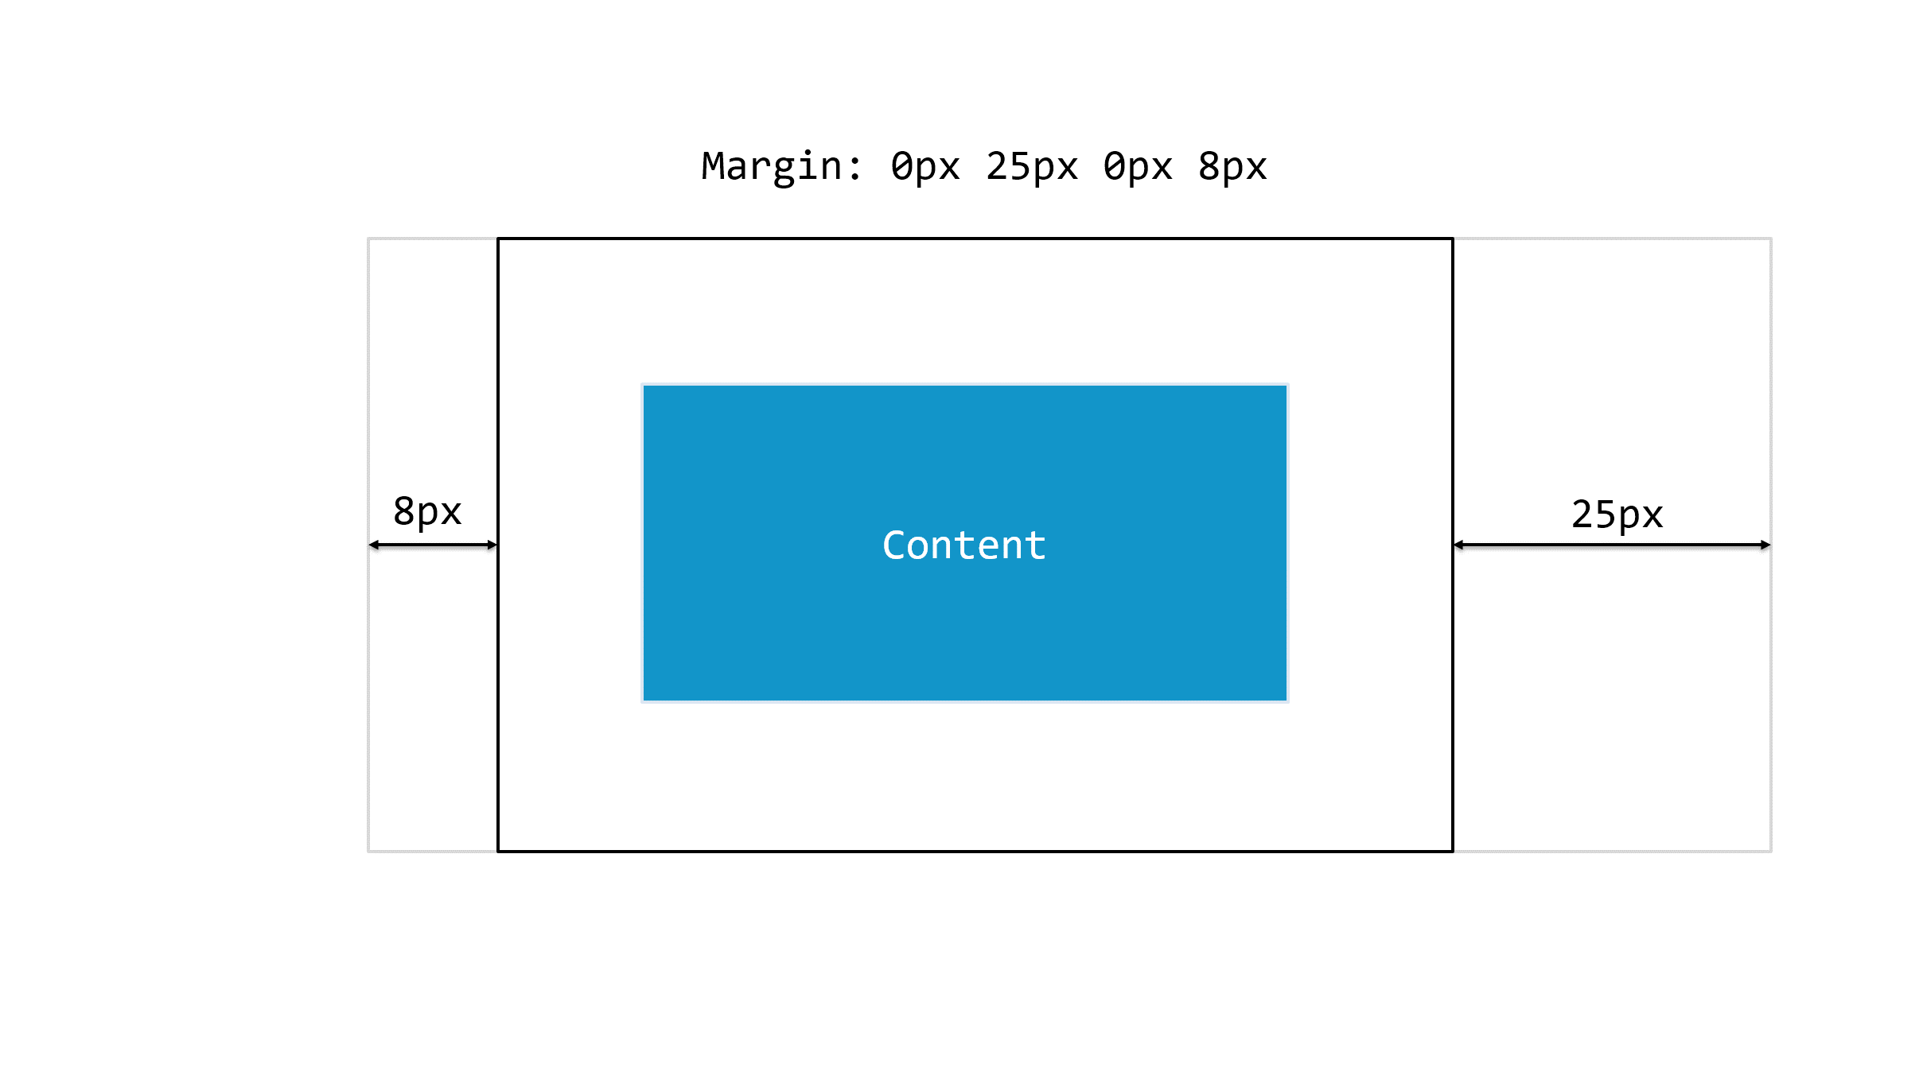
margin: 0px 8px 0px 25px;

